**Stoltenberg attends power plant ceremony on Turkey visit**

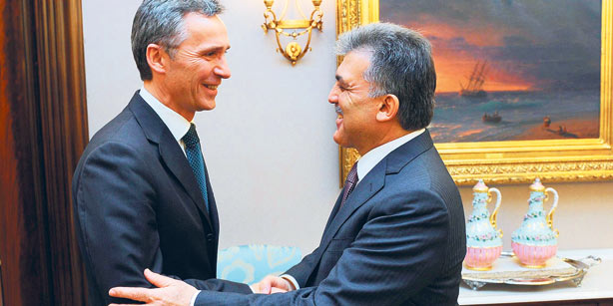

Norwegian Prime Minister Jens Stoltenberg also met with President Abdullah Gül on Monday. (Photo: AA)

9 January 2012 / TODAY'S ZAMAN, ANKARA

Norwegian Prime Minister Jens Stoltenberg has arrived in Turkey on a two-day official visit to discuss bilateral relations and other global issues with Turkish officials, as well as to participate in a ceremony for a hydroelectric station that a Norwegian company will build in an Anatolian city.

Stoltenberg arrived in Turkey on Monday upon an invitation by his Turkish counterpart, Recep Tayyip Erdoğan, and had separate talks with him and President Abdullah Gül on state-to-state relations as well as regional developments, including the fight against global terrorism and a resolution of the Cyprus issue. Stoltenberg also paid a visit to main opposition Republican People's Party (CHP) leader Kemal Kılıçdaroğlu on Monday and held a joint press conference with Parliament Speaker Cemil Çiçek in the afternoon.

While Çiçek raised the possibility of joint investments to be made by Norway and Turkey in third countries, Stoltenberg said he was impressed by Turkey's economic growth and added that the countries could pursue joint projects in the energy sector, the Anatolia news agency reported.

Stoltenberg is also expected to visit the Anatolian province of Çorum, where one of the major Norwegian energy companies, Statkraft, will build a hydroelectric power station, but was unable to travel to the city due to adverse weather conditions. Stoltenberg instead participated in the promotional ceremony through a teleconference from Ankara, as Turkish Energy and Natural Resources Minister Taner Yıldız hailed Norwegian partnership in Çorum, saying Turkey was ready to cooperate further with Norwegian firms, including an oil and natural gas research project in the Mediterranean and Black Seas.

**Erdoğan prefers ex-army chief's trial to continue without arrest**

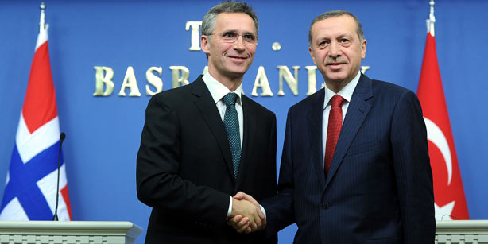

Turkish Prime Minister Recep Tayyip Erdoğan (R) and his Norwegian counterpart Jens Stoltenberg addressed the media in Ankara on Monday. (Photo: AA)

9 January 2012 / TODAYSZAMAN.COM,

Turkish Prime Minister Recep Tayyip Erdoğan has said it is his and his ruling party's preference that the trial of Turkey's ex-military chief, Gen. İlker Başbuğ, as part of the anti-government Internet campaign probe continue without his arrest.

Başbuğ testified last Thursday as a suspect in an investigation into an alleged Internet campaign to discredit Erdoğan's Justice and Development Party (AK Party). The prosecutors referred him to a court after questioning him for more than seven hours and he was arrested early on Friday.

Retired Gen. Başbuğ, who retired in 2010, is the highest-ranking officer to be caught up in a widening probe into the Ergenekon network, an ultra-nationalist group accused by prosecutors of conspiring to topple the government. Başbuğ is facing charges of “gang leadership” and seeking to unseat the government by force.

Erdoğan was speaking at a joint news conference with his Norwegian counterpart on Monday and said it is not appropriate for him to say something regarding an ongoing investigation, implying that his remarks could mean an intervention in judicial proceedings. Erdoğan added that he had worked with Başbuğ for two years and that it is his and his ruling party's preference that his trial continue without his detention.

The investigation into the propaganda websites began in 2010 based on evidence found in the home of retired Col. Hasan Ataman Yıldırım, another suspect in the website case. Later, an anonymous tipster from inside the military sent an email to inform the public and prosecutors that the General Staff had established 42 websites for the sole purpose of disseminating propaganda about the government and religious communities.

It was the first time a former chief of the armed forces has testified as a suspect in a criminal case in a civilian court. Several hundred defendants, including retired senior officers, lawyers, academics and journalists, have been put on trial in cases relating to the investigation.

Nicknamed pashas, a title dating back to Ottoman times, Turkey's once untouchable generals have seen their influence decline as Ankara pushes reforms aimed at strengthening civilian rule and winning Turkey's accession to the European Union. Turkey's military, NATO's second-largest army, has long seen itself as the guarantor of the country's secular constitution, and carried out three coups between 1960 and 1980 and pressured another government to step down from power in 1997.

The current investigation, carried out by state prosecutors, centers on allegations that Turkey's military set up websites to spread anti-government propaganda to destabilize Turkey. The court case is open and defendants are already on trial, but there was no hearing on Thursday. Başbuğ remains only a suspect and has not been charged.

The chief of General Staff from 2008 to 2010, he has in the past said reports of military plots to undermine the government were part of a smear campaign to divide the armed forces and pledged he would never tolerate coup activities. The “Internet Memorandum” case is just one of many strands of the investigation into Ergenekon which began five years ago. Retired Gen. Hilmi Özkök, also a former chief of General Staff, testified in the Ergenekon case in 2009, but only as a witness, not a suspect.

Erdoğan warns of civil war in Syria

Erdoğan also said during the news conference that Syria was heading for civil war and that Turkey should play a leading role in preventing this, in one of Ankara's starkest warnings over the violent uprising against President Bashar al-Assad. “The situation in Syria is heading towards a religious, sectarian, racial war, and this needs to be prevented,” Erdoğan told reporters. “Turkey has to take on a leadership role here, because the current situation poses a threat to Turkey.”

NATO member Turkey, which shares a 910-kilometer (550 miles) long border with Syria and is exerting growing diplomatic and economic influence in the Arab world, is reluctant to take any unilateral military action in Syria, but is fearful escalating fighting there could escalate to a broader sectarian regional conflagration. Erdoğan, who has called on former friend Assad to step down and has slapped sanctions on Damascus, did not say what Ankara would do to prevent the country from descending into civil war.

Ankara has floated the idea of setting up a “buffer zone” on Syrian soil if fighting triggers a flood of refugees posing an immediate threat to Turkey's security. But even then, Turkey has said it would seek United Nations backing. There are fears not only in Turkey that Syria's ethnic and sectarian mosaic could disintegrate and plunge the country of 22 million into chaos.

Turkish senior foreign ministry officials are also concerned Syria could become a new front line in a regional rivalry between Sunni powerhouse Saudi Arabia and Syria's ally, Shi'ite Iran. Last week, Foreign Minister Ahmet Davutoğlu warned against a sectarian Cold War in the region and said raising Sunni-Shi'ite tensions would be suicide for the whole region.

Norway's Prime Minister Jens Stoltenberg told reporters that there is a need to increase international pressure to force Assad to step down over his regime's deadly crackdown on anti-government protesters.

Activists said on Monday that Syrian troops fired on protesters in the restive city of Homs as Arab League observers toured the area to see if Assad's regime is abiding by its pledge to halt the crackdown. Activists reported that at least 19 people were killed, including three rebels, two women and a minor.

**Norwegian PM condemns terrorism in İstanbul meeting**

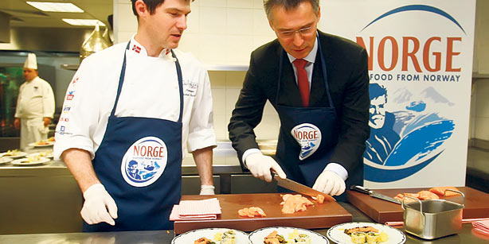

Norwegian PM Jens Stoltenberg prepares salmon dishes with Norway Kitchen Academy Manager Jostein Medhus during a lunch organized in his honor at Çırağan Palace. (Photo: Cihan)

10 January 2012 / GÖZDE NUR DONAT, İSTANBUL

Norwegian Prime Minister Jens Stoltenberg emphasized the cruelty of terrorist activities, in reference to the July 22 terrorist attack which claimed 77 lives in Norway and was committed as a plot against a multicultural Europe, during a lunch organized in his honor at İstanbul's Çırağan Palace Kempinski Hotel on Tuesday.

The prime minister also reiterated his condolences to Turkey for the attack, which took the life of 17-year-old Turk Gizem Doğan, and said he commiserates with Turkey regarding the terrorist Kurdistan Workers’ Party (PKK) attacks, which have claimed many lives.

Stoltenberg helped with the cooking of the lunch, in which Norwegian seafoods were presented. He cooked Norwegian salmon in the hotel’s kitchen, accompanied by Jostein Medhus, a famous Norwegian chef. Medhus said Stoltenberg is a very talented cook. The prime minister said he learned to cook during his childhood, explaining this is where his cooking talent comes from.

Saying that Turkish foods are very delicious, the prime minister said he liked the “hamsi,” the anchovies renowned in Turkey’s Black Sea region, that he ate yesterday during a visit to Ankara.

Stoltenberg held meetings on Monday with President Abdullah Gül, Prime Minister Recep Tayyip Erdoğan and Parliamentary Speaker Cemil Çiçek, as well as main opposition Republican People’s Party (CHP) leader Kemal Kılıçdaroğlu, during his Ankara visit.

During his talk with Çiçek in the Parliament building, Stoltenberg hailed Turkish initiatives to replace the 1982 military constitution, which was prepared by an interim military government following the Sept. 12, 1980 coup. “We are gladly following Turkey’s democratic progress. Turkey has made significant developments in human rights in recent years,” the prime minister said, in particular citing current draft regulations in Turkey concerning women’s rights.

However, Stoltenberg also said that Turkey still needs improvement on freedom of expression, and he criticized the arrests of journalists, which he depicted as an obstacle to freedom of the press. In response to Stoltenberg, Çiçek said: “These people have not been arrested due to their journalist activities. Most of them are suspected of serious crimes, including serving the goals of terrorist groups,” citing the journalists’ suspected links to Ergenekon, a clandestine terrorist organization charged with attempting to overthrow the government.