**Norwegian PM stresses democracy, rule of law**

ISTANBUL - Hürriyet Daily News

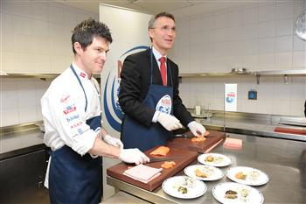

The Norwegian Prime Minister Jens Stoltenberg cooked sashimi (raw salmon) with Norwegian cook Jostein Medhus in the Çırağan Palace kitchen in Istanbul. DAILY NEWS photo, Emrah GÜREL

İpek Yezdani **ipek.yezdani@hurriyet.com.tr**

Restrictive press freedom in Turkey was one of the items on the agenda of the meeting between Norwegian Prime Minister Jens Stoltenberg and Turkish Prime Minister Recep Tayyip Erdoğan, Stoltenberg said.  
  
“It is important all these people are tried in independent courts based on the rule of law,” the Norwegian prime minister told Hürriyet Daily News in an interview yesterday regarding the concerns over the arrested journalists in Turkey.   
  
During his meeting with Parliament Speaker Cemil Çiçek in Ankara on Monday, Stoltenberg praised Turkey’s democratic progress but questioned respect for free speech and media freedom, joining mounting international misgivings over Ankara’s record.   
  
Stoltenberg also said that during his meeting with Erdoğan they agreed to establish a dialogue on human rights through the United Nations and European Council.   
  
The visiting prime minister avoided making any comments on the move of the public prosecutor in Silivri to file a case against main opposition Republican People’s Party (CHP) leader Kemal Kılıçdaroğlu. “The most important thing is democracy and rule of law,” Stoltenberg said.   
  
Stoltenberg also attended a luncheon yesterday that was hosted in his honor at Çırağan Palace in Istanbul.   
Before the luncheon, the Norwegian premier cooked sashimi (raw salmon) with Norwegian cook Jostein Medhus in the Çırağan Palace kitchen. Stoltenberg said he also tried Turkish seafood and liked it very much.   
  
Stoltenberg proceeded from Istanbul to Yalova city with Turkish Transportation Minister Binali Yıldırım to attend a ceremony to launch a Norwegian-Turkish ship that was constructed at Yalova Tersan Shipyard.  
  
Stoltenberg also talked about the Turkish girl Gizem Doğan who was killed in the two sequential terrorist attacks against the government, the civilian population and a summer camp in Norway on July 22, 2011.  
  
Anders Behring Breivik, a 32-year-old Norwegian right-wing extremist, is currently on trial for the attacks that killed 77 people.  
  
“Turkey is one of the countries which know best how dangerous and cruel terror can be. Now Norway also knows how dangerous and how cruel terrorism is,” Stoltenberg said.

***January/11/2012***

**Norwegian PM slams Turkey over free press**

ANKARA

**Despite major advancements in human rights and women’s rights in recent years, Turkey faces ‘difficulties regarding freedom of expression,’ says Jens Stoltenberg**

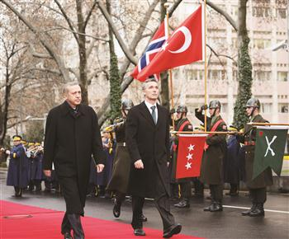

Prime Minister Recep Tayyip Erdoğan (L) and Norwegian Prime Minister Jens Stoltenberg walk in front of the prime mninister’s office in Ankara in an offical welcoming ceremony. Stoltenberg criticized yesterday the situation of press freedom in Turkey. DAILY NEWS photo, Selahattin SÖNMEZ

Norwegian Prime Minister Jens Stoltenberg has praised Turkey’s democratic progress but questioned respect for free speech and media freedoms, joining mounting international misgivings over Ankara’s record.  
  
Despite major advancements in human rights and women’s rights in recent years, Turkey faces “difficulties regarding freedom of expression, as many other countries have pointed out. The subject of whether journalists are working freely is also an issue,” Stoltenberg said during talks with Parliament Speaker Cemil Çiçek yesterday.  
  
Çiçek responded the majority of jailed journalists were charged for terror-related offenses and not for their reporting activities and slammed European countries for failing to give Turkey adequate support against the outlawed Kurdistan Workers’ Party (PKK).  
  
“There is a misevaluation regarding journalists. They are not in prison for doing their job. They are in prison for being members of a terrorist organization, forging documents and other such illegal activities. Evaluating them as journalists would be a serious mistake,” he said.  
  
Referring to a court case in Denmark against Roj TV, the alleged mouthpiece of the PKK, Çiçek said the station was already making efforts to find itself a new base in another Scandinavian country in case it is banned in Denmark. “We hope our friends in Norway will show greater sensitivity to our fight against terror,” he said.  
  
“Unfortunately, there isn’t sufficient international cooperation in the fight against terror. The terrorist organization receives a considerable amount of support from Europe,” Çiçek added.  
  
In further remarks, Stoltenberg praised Turkey’s economic growth, stressing that bilateral cooperation could be expanded especially in the energy, shipbuilding and seafood sectors.  
  
The government’s democratic credentials were also on the agenda of Stoltenberg’s meeting with main opposition leader Kemal Kılıçdaroğlu, sources of the Republican People’s Party (CHP) said. Voicing his concerns, Kılıçdaroğlu stressed lengthy pre-trial detentions had become a punishment in themselves and the special-authority courts had degenerated into a government tool to bully and silence critics. “Those issues are very important and should be carefully followed,” Stoltenberg was quoted as saying in response.  
  
Later in the day, the Norwegian leader also held talks with Prime Minister Recep Tayyip Erdoğan. Their meeting was still under way when Hürriyet Daily News went to print.

***January/10/2012***