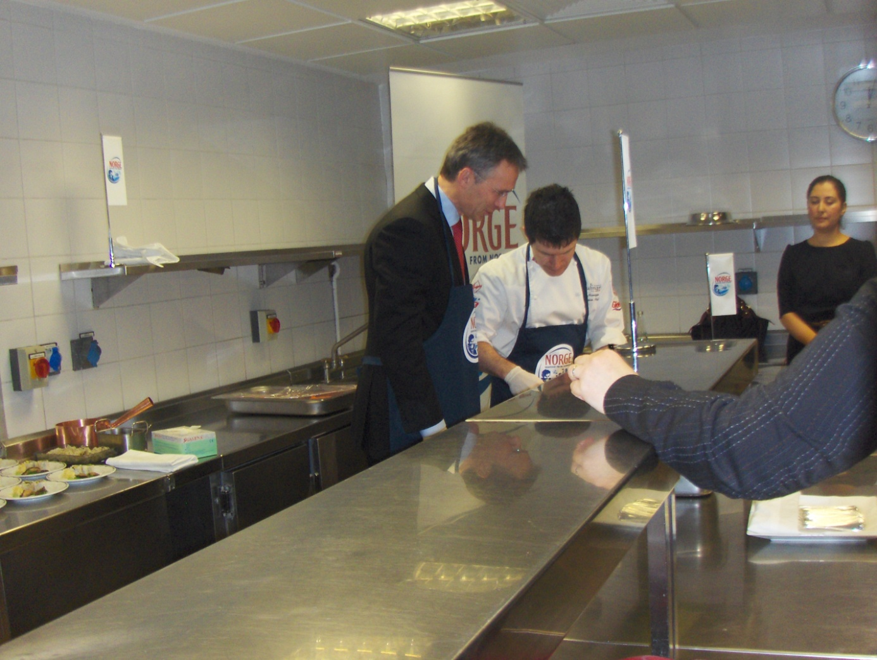 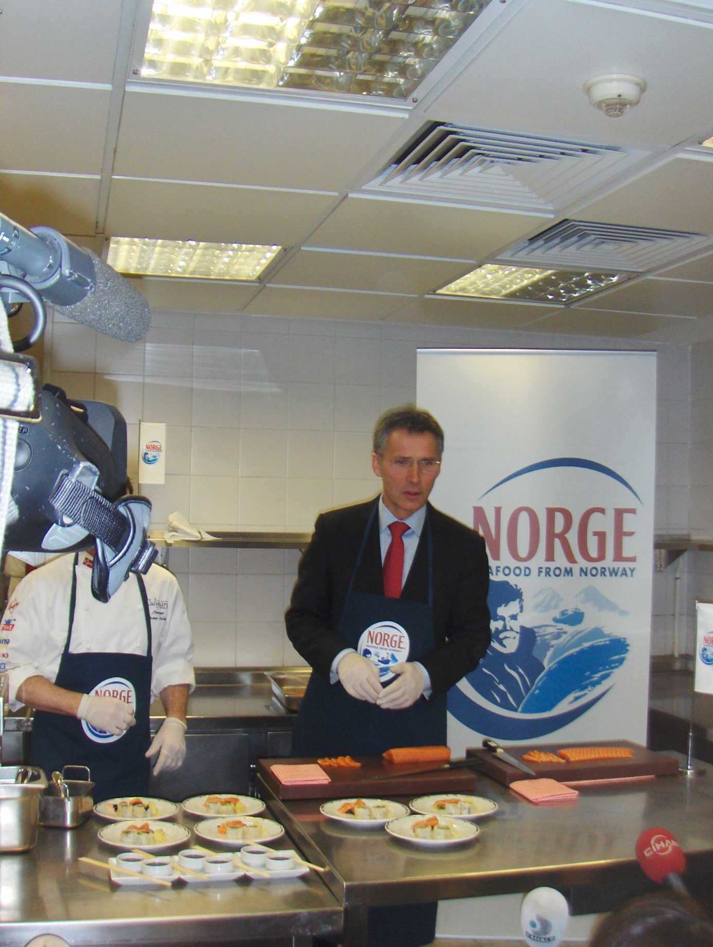

**Prime Minister Jens Stoltenberg cooked sashimi (raw salmon) with Norwegian cook Jostein Medhus in the Çırağan Palace kitchen in Istanbul.**

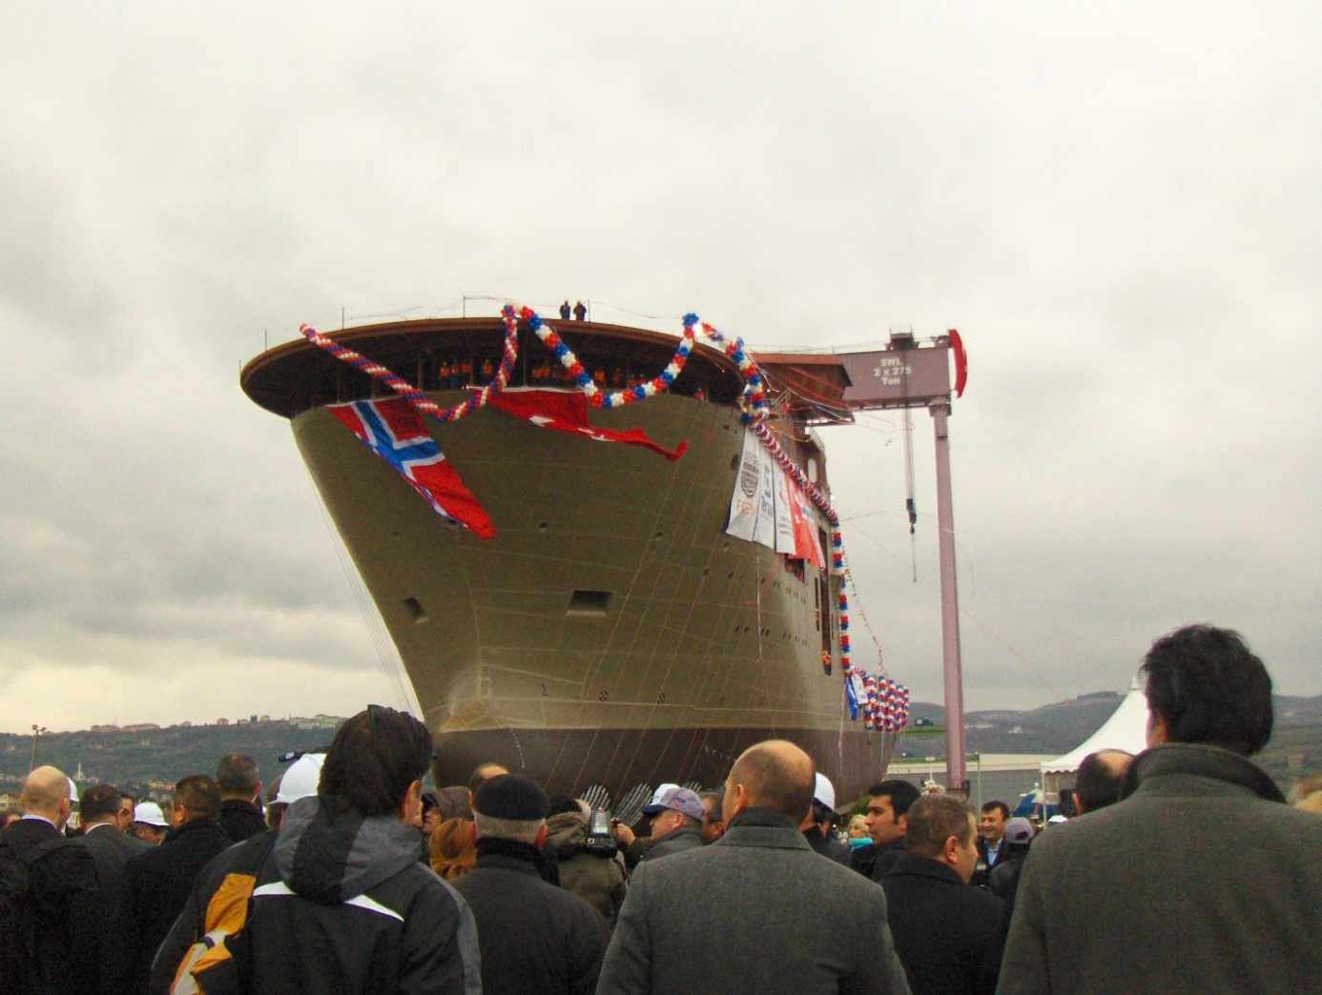 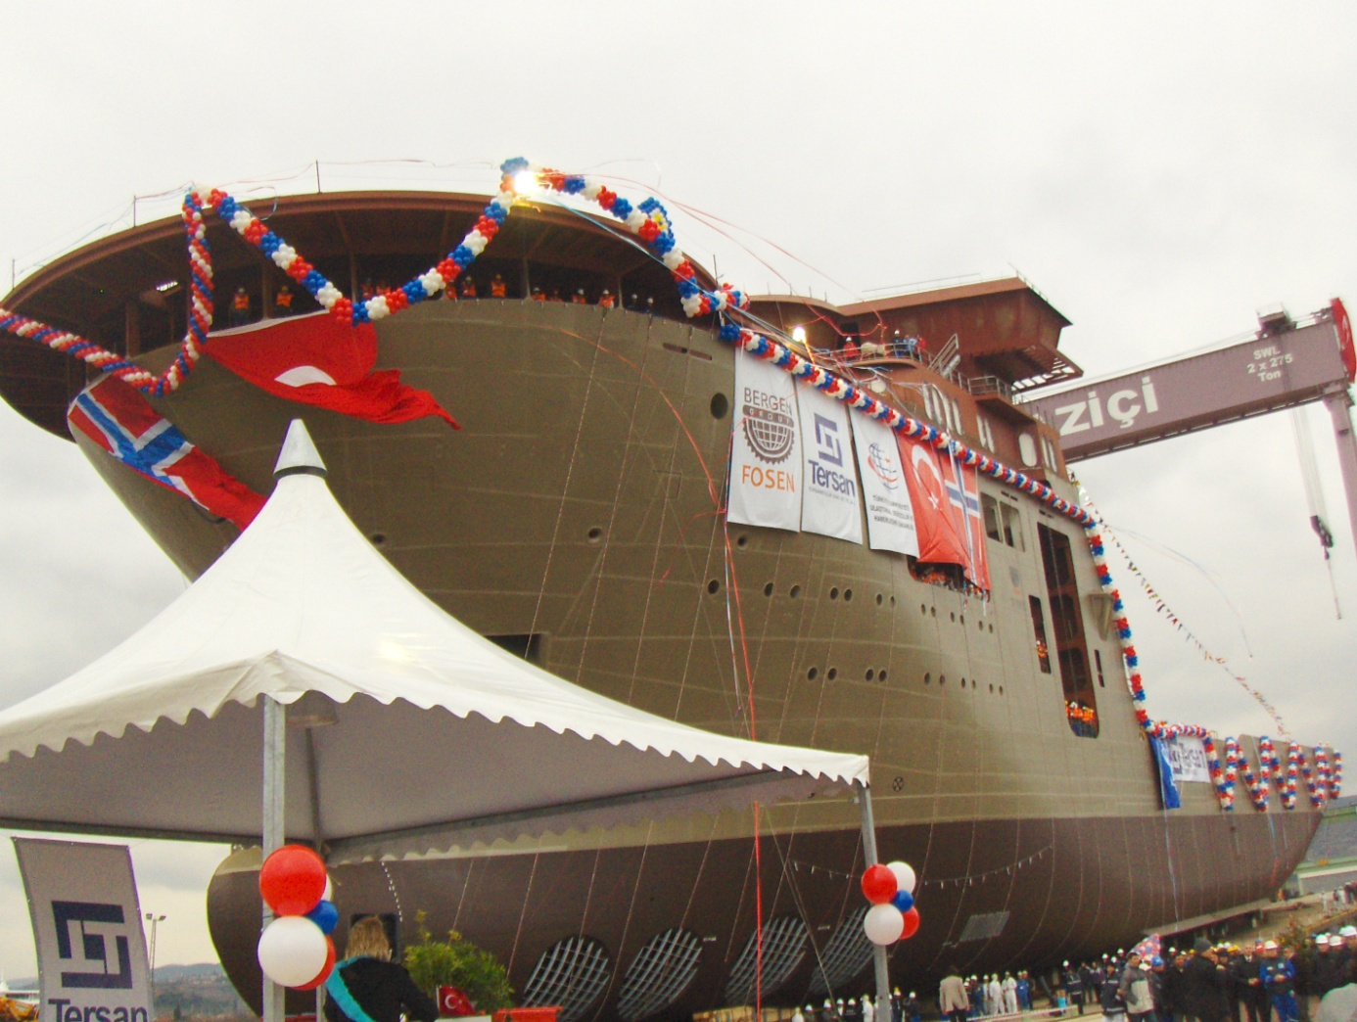

**Prime Minister Stoltenberg attend a ceremony together with Turkish Transportation Minister Binali Yıldırım to launch a Norwegian-Turkish ship “Grand Canyon” that was constructed at Yalova Tersan Shipyard.**

